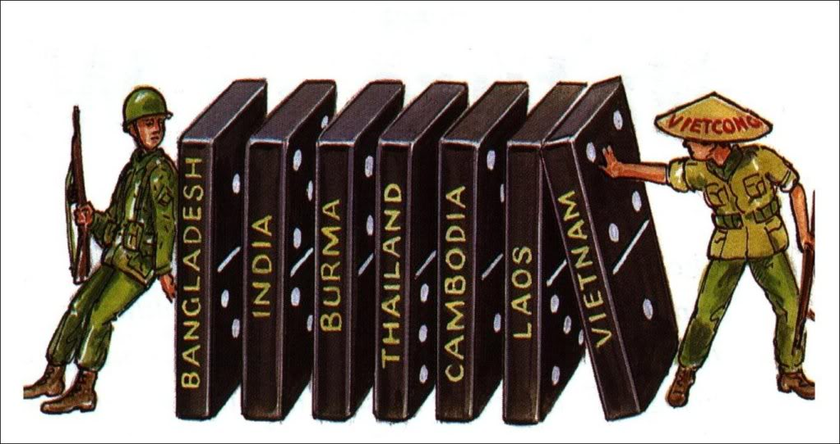
Cartoon Analysis – Domino Theory

1. What people do you see in the cartoon? How are they dressed?
________________________________________________________

2. What nations are labeled on the dominos?
__________________________________________________________________________________________

3. Knowing what you know about dominos, what would happen if “Vietnam” falls?
__________________________________________________________________________________________

4. Is the US helping or opposing the “dominos falling”?
HELPING OPPOSING

5. Which countries have already ‘fallen’?

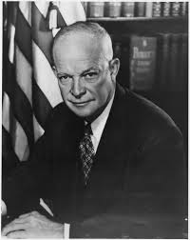
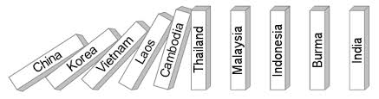
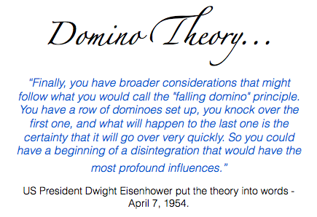

NZ VIEWPOINTS

“Communist aggression is a threat to us. If South Vietnam is overrun and becomes a Communist state it becomes the next move in the Communist plan for world revolution … Our security and way of life are at stake and we cannot stand aside.”
-Deputy PM Jack Marshall, 1963

“The Malay peninsula points like a finger in our direction with Indonesia and Australia s convenient stepping stones along the way. The sooner Communist China moves south, the sooner New Zealand and Australia will be directly threatened. If communism engulfs the Malay peninsula an irrevocable step will have to be taken…”
-NZ Minister of Defence, Dean Eyre to Parliament, 1964

