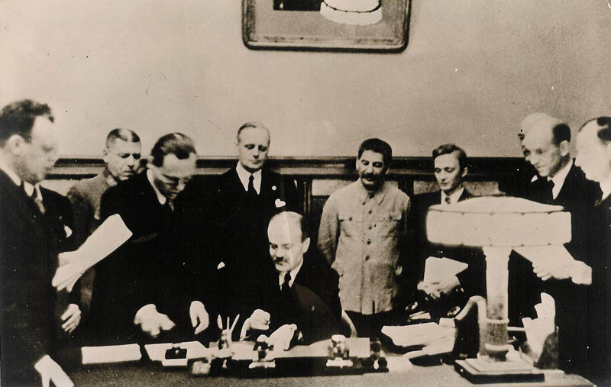
FROM ENEMIES TO ALLIES: THE USSR AND ‘THE WEST’ DURING WORLD WAR II
The Nazi-Soviet Non-Aggression Pact (aka Molotov-Ribbentrop Pact)
Stalin had been very worried about the German threat to the Soviet Union ever since Hitler came to power in 1933. Hitler had openly stated his interest in conquering Russian land. He had denounced communism and imprisoned and killed Communists in Germany. Even so Stalin could not reach any kind of lasting agreement with Britain and France in the 1930s. From Stalin’s point of view it was not for want of trying. In 1934 he had joined the League of Nations, hoping the League would guarantee his security against the threat from Germany. However, all he saw at the League was its powerlessness when Mussolini successfully invaded Abyssinia, and when both Hitler and Mussolini Molotov signs the Non-Aggression Pact, 1939
intervened in the Spanish Civil War. Politicians in Britain and France had not resisted German
rearmament in the 1930s. Indeed some seemed even to welcome a stronger Germany as a force to fight Communism, which they say as a bigger threat to British interests than Hitler.

Stalin’s fears and suspicions grew in the mid 1930s. He signed a treaty with France in 1935 which said that France would help the USSR if Germany invaded Russia. But Stalin was not sure he could trust the French to stick to it, particularly when they failed to even stop Hitler from moving into the Rhineland which was right on their own border.

For Stalin, the Munich Agreement in 1938 was the final straw. He was not consulted about it. Stalin concluded from the agreement that France and Britain were powerless to stop Hitler, or even worse, they were happy for Hitler to take over eastern Europe and then Russia. Stalin felt that Russian interests were ignored by Britain and France. So when Ribbentrop, a very senior Nazi (Foreign Minister) flew to Moscow for talks, Stalin decided that Russia’s interests would be better served by an agreement with Germany.

On 24 August 1939 Hitler and Stalin, the two arch-enemies, signed the Nazi-Soviet Pact. They announced to a stunned world that they had agreed not to attack one another. Privately and unknown to the rest of the world they also agreed to divided Poland between them.

Source: Walsh, B (ed.), GSCE Modern World History, John Murray Publishers Ltd, London, 1996, p. 224.

Operation Barbarossa
In Mein Kampf and in numerous speeches Adolf Hitler claimed that the German population needed more living space. Hitler's Lebensraum policy was mainly directed at the East where he believed Slavic peoples were subhuman.

Despite signing a non-aggression pact with Germany, Stalin knew he was only buying time. However, he believed that Germany would not invade the Soviet Union until Britain and France had been conquered. From Stalin's own calculations, this would not be until the summer of 1942. Some of his closest advisers began to argue that 1941 would be a much more likely date.

Stalin knew that if Adolf Hitler did not attack the Soviet Union in the summer of 1941 he would have to wait until 1942. No one, not even someone as rash as Hitler, would invade the Soviet Union in the winter, he argued.
The plan was for the invasion of the Soviet Union to start on the 15th May, 1941. Hitler believed that this would give the German Army enough time to take control of the country before the harsh Soviet winter set in.
Information on the proposed invasion came to Stalin from various sources. Even, Winston Churchill sent a personal message to Stalin in April, 1941, explaining how German troop movements suggested that they were about to attack the Soviet Union. However, Stalin was still suspicious of the British and thought that Churchill was trying to trick him into declaring war on Germany.

The Operation was delayed until 21st June, 1941 when the German forces, made up of three million men and 3,400 tanks, advanced in three groups. The north group headed for Leningrad, the centre group for Moscow and the southern forces into the Ukraine. Within six days, the German Army had captured Minsk. General Demitry Pavlov, the man responsible for defending Minsk, and two of his senior generals were shot for incompetence. In future, Soviet commanders thought twice about surrendering or retreating. Terrified of both Stalin and Hitler, the Soviet people had no option but to fight until they were killed.

The first few months of the war was disastrous for the USSR. The German northern forces surrounded Leningrad while the centre group made steady progress towards Moscow. German forces had also made deep inroads into the Ukraine. By the time Kiev was taken, the casualties were extremely high. It was the most comprehensive defeat experienced by the red army in its history. However, the determined resistance put up at Kiev, had considerably delayed the attack on Moscow. As German troops moved deeper into the Soviet Union, supply lines became longer. Stalin gave instructions that when forced to withdraw, the Red Army should destroy anything that could be of use to the enemy. The scorched earth policy and the formation of guerrilla units behind the German front lines, created severe problems for the German war machine

By October, 1941, German troops were only fifteen miles outside Moscow. Orders were given for a mass evacuation. In two weeks, two million people left Moscow and headed east. Stalin rallied morale by staying. In November, 1941, the German Army launched a new offensive on Moscow. The Soviet army held out and the Germans were brought to a halt. Stalin called for a counter-attack. The German army, demoralized by its recent lack of success, was taken by surprise and started to retreat. By January, the Germans had been pushed back 200 miles.

The USSR was saved by dogged Russian resistance and the freezing harsh winter which the Germans were not as accustomed to or prepared for. The German invasion of the Soviet Union laid the ground work for the formation of a Grand Alliance between Britain, the USSR and the USA who entered the war in December 1941 following the attack on Pearl Harbour.
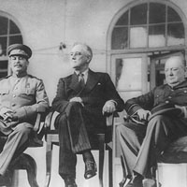

The Tehran Conference, 1943
The Tehran Conference was a meeting between U.S. President Franklin Delano Roosevelt, British Prime Minister Winston Churchill, and Soviet Premier Joseph Stalin in Tehran, Iran, between November 28 and December 1, 1943. During the Conference, the three leaders coordinated their military strategy against Germany and Japan and made a number of important decisions concerning the post World War II era.

Roosevelt, Churchill, and Stalin engaged in discussions concerning the terms under which the British and Americans finally committed to launching Operation Overlord, an invasion of northern France, to be executed by May of 1944. The Soviets, who had long been pushing the Allies to open a second front, agreed to launch another major offensive on the Eastern Front that would divert German troops away from the Allied campaign in northern France. Stalin also agreed in principle that the Soviet Union would declare war against Japan following an Allied victory over Germany

At Tehran, the three Allied leaders also discussed important issues concerning the fate of Eastern Europe and Germany in the postwar period. Stalin pressed for a revision of Poland's eastern border with the Soviet Union to match the line set by British Foreign Secretary Lord Curzon in 1920. In order to compensate Poland for the resulting loss of territory, the three leaders agreed to move the German-Polish border to the Oder and Neisse rivers. This decision was not formally ratified, however, until the Potsdam Conference of 1945. During these negotiations Roosevelt also secured from Stalin his assurance that the Republics of Lithuania, Latvia, and Estonia would be reincorporated into the Soviet Union only after the citizens of each republic voted on the question in a referendum. Stalin stressed, however, that that the matter would have to be resolved "in accordance with the Soviet constitution," and that he would not consent to any international control over the elections.

Broader international cooperation also became a central theme of the negotiations at Tehran. Roosevelt and Stalin privately discussed the composition of the United Nations. During the Moscow Conference of the Foreign Ministers in October and November of 1943, the United States, Britain, China, and the Soviet Union had signed a four-power declaration whose fourth point called for the creation of a "general international organization" designed to promote "international peace and security." At Tehran, Roosevelt outlined for Stalin his vision of the proposed organization in which the future United Nations would be dominated by "four policemen" (the United States, Britain, China, and Soviet Union) who "would have the power to deal immediately with any threat to the peace and any sudden emergency which requires action."

Source: http://history.state.gov/milestones/1937-1945/TehranConf, ‘Tehran Conference’, (date accessed: 16 January 2011)

FROM ENEMIES TO ALLIES: THE USSR AND ‘THE WEST’ DURING WORLD WAR II
INSTRUCTIONS Next to the pictures show how the relationship between the USSR, Britain, the USA and between the USSR and Germany changed during the course of World War II. Use the questions next to each image to help guide your response.
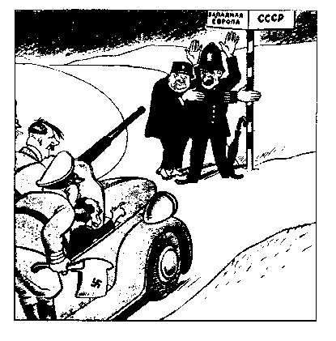
What were Soviet attitudes towards Britain and France in the 1930s?

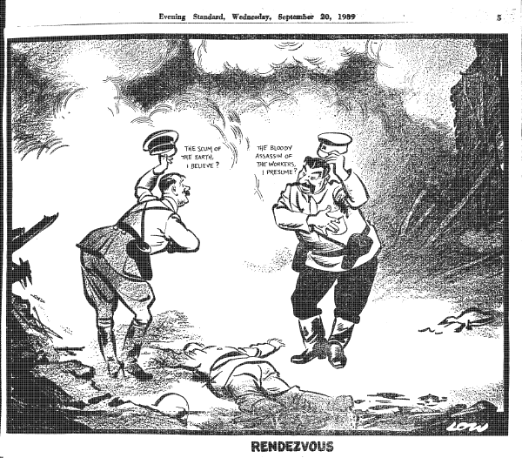
How did Hitler and Stalin really view each other?

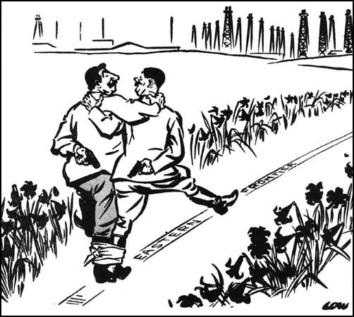
What was the Nazi-Soviet Non-Aggression Pact and why was it signed?

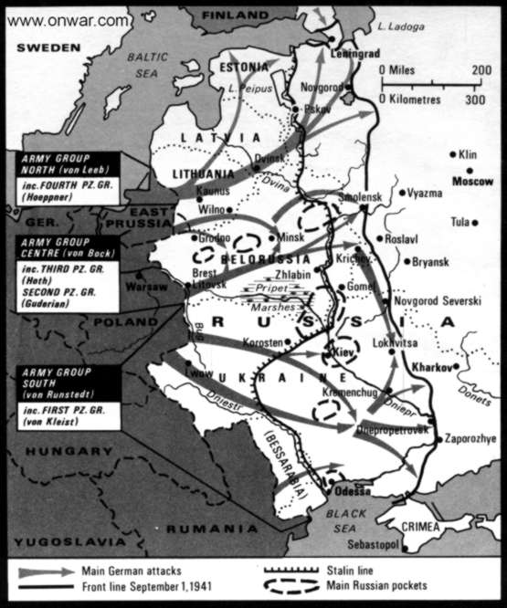
What was Operation Barbarossa and how did it change the Allies’ relationship with the USSR?

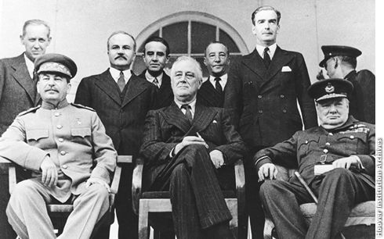
What was agreed to at the Tehran Conference, 1943?

What problems do you foresee for this ‘Grand Alliance’?

