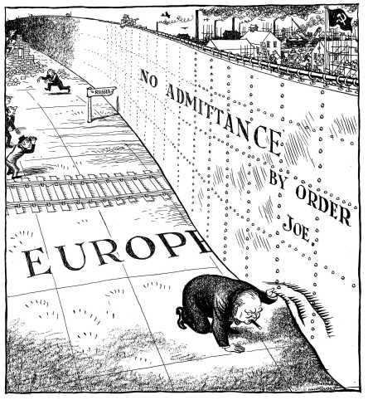
The Iron Curtain
The Iron Curtain, Truman Doctrine & Marshall Plan

“… I have a strong admiration and regard for the valiant Russian people and for my wartime comrade, Marshall Stalin. There is deep sympathy and goodwill in Britain -- and I doubt not here also -- towards the peoples of all the Russias and a resolve to persevere through many differences and rebuffs in establishing lasting friendships. We understand the Russian need to be secure on her western frontiers by the removal of all possibility of German aggression. We welcome Russia to her rightful place among the leading nations of the world. We welcome her flag upon the seas. Above all, we welcome, or should welcome, constant, frequent and growing contacts between the Russian people and our own people on both sides of the Atlantic.
It is my duty however, for I am sure you would wish me to state the facts as I see them to you. It is my duty to place before you certain facts about the present position in Europe.
From Stettin in the Baltic to Trieste in the Adriatic an iron curtain has descended across the Continent. Behind that line lie all the capitals of the ancient states of Central and Eastern Europe. Warsaw, Berlin, Prague, Vienna, Budapest, Belgrade, Bucharest and Sofia, all these famous cities and the populations around them lie in what I must call the Soviet sphere, and all are subject in one form or another, not only to Soviet influence but to a very high and, in some cases, increasing measure of control from Moscow. …”
W. Churchill 5 March 1946

- Why does Churchill have ‘strong regard and admiration’ for Stalin?

- What does Churchill mean by the use of the term ‘Iron Curtain’?

- What do you think was the purpose of this speech?

- Was this a declaration of Cold War?

USSR
Countries under Communist controlled Governments
Iron Curtain

Between 1945 and 1947 elections were held in may eastern European countries. One, by one, Communist parties came to power. The West thought the elections were ‘rigged’. In some cases, they were. The West may have been able to intervene militarily but the people of Britain and the USA would not even consider another war.
Initially the Iron Curtain was only a barrier of ideas. It did not stop the movement of people. Between 1949 and 1952 over 600 000 people moved from East to West. In May 1952 Communist East Germany decided to block off its western border. Barbed wire fences were erected to prevent skilled East Germans fleeing West and to stop the spread of non communist ideas East. Soon, the only safe route between East and West was in Berlin where the boundary stayed open. Berlin was located in the centre of East Germany but it too was divided into four zones of occupation.
The Truman Doctrine and Containment

In 1947 Europe was still not completely free from war. Civil war raged in Greece, the USSR was putting pressure on Turkey and Communism was getting close to the Middle East.
In March 1947 President Truman gave a speech to the US Congress, known as the Truman Doctrine.
“… The peoples of a number of countries of the world have recently had totalitarian regimes forced upon them against their will. The Government of the United States has made frequent protests against coercion and intimidation, in violation of the Yalta agreement, in Poland, Rumania, and Bulgaria. I must also state that in a number of other countries there have been similar developments.

At the present moment in world history nearly every nation must choose between alternative ways of life. The choice is too often not a free one.

One way of life is based upon the will of the majority, and is distinguished by free institutions, representative government, free elections, guarantees of individual liberty, freedom of speech and religion, and freedom from political oppression.

The second way of life is based upon the will of a minority forcibly imposed upon the majority. It relies upon terror and oppression, a controlled press and radio; fixed elections, and the suppression of personal freedoms.
I believe that it must be the policy of the United States to support free peoples who are resisting attempted subjugation by armed minorities or by outside pressures. …”

Highlight the section which is talking about the West
Highlight the section which is talking about the East

The Truman Doctrine established the US policy of containment – the idea of holding back the spread of communism.

An example of the US’s policy of containment can first be seen in the Marshall Plan.
The Marshall Plan

By 1947 much of Europe still lay in waste. Communist parties in France and Italy were gaining strength and there was a fear that communism was spread to Western Europe. In 1947 US General George Marshall came up with the Marshall Plan. It offered US aid wherever it was needed. The aid was offered to all countries, even the USSR, although the USA never thought the USSR would seriously accept. Stalin refused to allow any Eastern European countries to share in Marshall Aid believing it to be, ‘a plan for political pressure with the help of dollars…for interference in the affairs of other countries’.

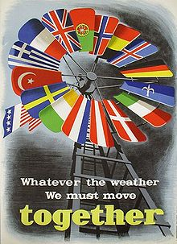
Western Europe jumped at the offer and 16 countries drew up the OEEC (Organisation for European Economic Cooperation) to help distribute the aid. 13 million dollars worth of food, fertilisers, vehicles and fuel flowed into Western Europe. Marshall Aid had effectively strengthened the West against Communism.

The USSR saw the plan as: “widely advertised as a ‘plan to save peace’, was aimed at uniting countries on an anti-Soviet basis…a new alliance against communism”.

The West Germans saw it differently: “The Marshall Plan will go down in History as one of America’s greatest contributions to the peace of the world…”Source: Fisher, P., The Great Power Conflict After 1945, Basil Blackwell, Kent, 1985.

