WHY WAS THE BERLIN WALL BUILT?

Between 1950 and 1960 roughly how many East Berliners defected to West Berlin?
1950 1951 1952 1953 1954 1955 1956 1957 1958 1959 1960 1961 1962 1963 1964

What year do you think the Berlin Wall went up? How do you know?

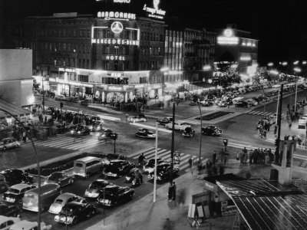
During the 1950s East Germans were able to travel freely into West Berlin. From there they could travel to West Germany. However, an increasing number were not returning and those who were leaving were often highly skilled workers. The sight of thousands leaving East Germany for a life under capitalism undermined Communism in East Germany and in general. The Western powers also made sure East Germans could see the prosperity of West Berlin – shops full of goods, freedom, wealth and variety. East Germans had access to West German television and could see what life was like in the West. Living standards were tolerable in the East, but they were better just a few hundred meters away in the West. With the help of Marshall Aid, West Germany (and West Berlin) were being rebuilt quickly, in stark contrast to East Germany.
Berlin was clearly a gaping hole in the Iron Curtain. Russia used the excuse that West Germany was getting too powerful in order to solve the Berlin problem.
Measures have been taken…in the interests of peace in Europe and the security of the GDR [East Germany] and other socialist states.
Before everyone’s eyes West Germany is becoming a seat of war and danger in Europe. A regular army headed by former Hitler generals has sprung up there. Today West Germany has the largest army on the European continent among the NATO countries.

Russian Government, 3 August 1961. East German Radio broadcast, 13 August 1961
THE WALL GOES UP
The East German government, under directions from Russia, acted. On the evening of 13 August 1961 armoured trucks carrying guards approached the invisible borders with the western zones and uncoiled large rolls of barbed wire. By the morning, the border with the West was effectively closed and the city had been cut in two. A few crossing points stayed open, protected by tanks, armoured cars and water cannon. West Berliners looked to the USA and the newly elected President, John F. Kennedy, for answers. Vice President Johnson flew to Berlin. The US protested to Russia about the wall, but Kennedy was not willing to risk war over Berlin, “The crisis is over. If the Russians wanted to attack us and cut off the access routes, they wouldn’t be putting up barbed wire borders…I’m not going to get het up about it.”
By 17 August the barbed wire began to be replaced with stone. The construction of the Berlin Wall had begun. Where houses formed the border their windows were bricked up. The wall succeeded in stopping the flood of defectors, but some were still determined. 41 people were shot trying to cross the wall in its first year.
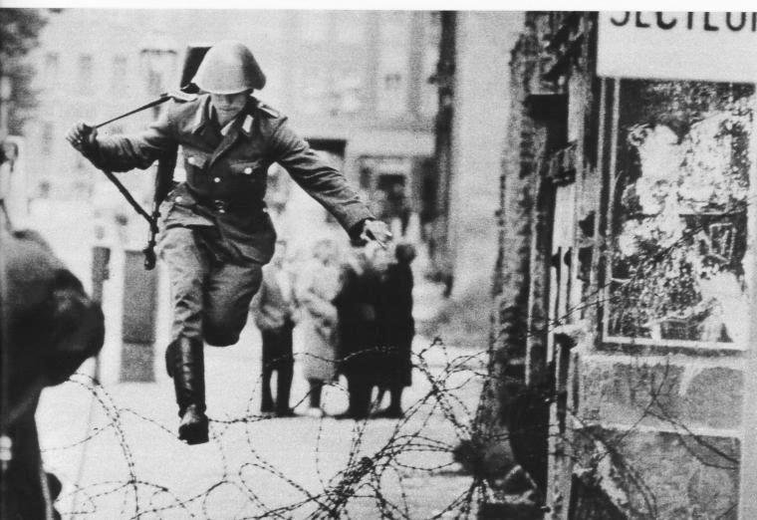
- When was this photo taken? (Be as accurate as possible)

- What event has been captured?

- Which government do you think the soldier belongs to? Why?

- What is he doing? Why?

A great city has been slashed in two by a big ugly barrier eight feet high. At regular interval are watch towers manned by policemen with machine guns, on the look out for anyone trying to escape what is now, the huge penitentiary of the Soviet Union.
The Western powers in Berlin use it as a centre of subversive activity against the GDR. In no other part of the world are so many espionage centres to be found. These centres smuggle their agents into the GDR for all kinds of subversion: recruiting spies; sabotage; provoking disturbances. The government presents all working people of the GDR with a proposal that will securely block subversive activity so that reliable safeguards and effective control will be established around West Berlin, including its border with democratic Berlin.

There are some who say, in Europe and elsewhere, we can work with the Communists. Let them come to Berlin.

The frontiers of our republic will be protected at all cost. We will do everything to stop the criminal activities of Western Germany and the American spies.
TASK: Label each quote as either as Soviet view or a Western view.

