THE YALTA CONFERENCE, FEBRUARY 1945
The ‘Big Three’ agreed to:
i

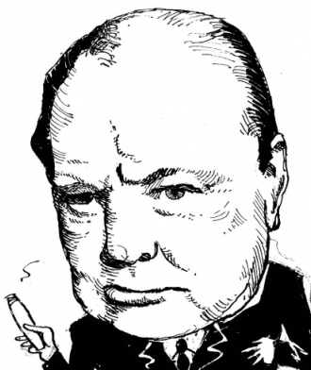
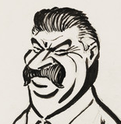
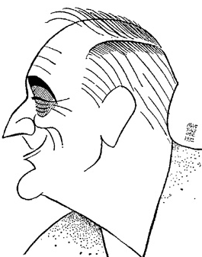

WHAT WERE THEY REALLY THINKING ABOUT EACH OTHER?
(Colour code each leader’s thought bubbles first to make it easier)

